PRESS RELEASE: 83rd Annual Georgetown House Tour Date Announced

Saturday, April 26, 2014

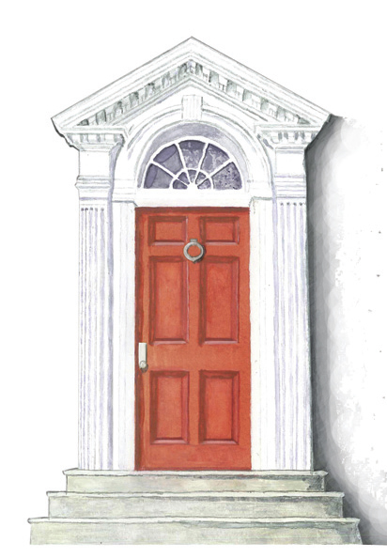
The Georgetown House Tour, celebrating its 83rd year, is the oldest, most prestigious house tour in the country. The tour gives locals and out-of-towners alike the opportunity to visit 18th and 19th century historic homes graciously opened for this event. This year’s Georgetown House Tour, hosted by the historic St. John’s Episcopal Church, Georgetown Parish is scheduled for 11 a.m. to 5 p.m., Saturday, April 26th. Nine historic residences will be on the tour.

Barbara Wolf and Colman Riddell are co-chairing this year’s tour. “This year’s highly informational walking tour will provide an opportunity to take in all the history and beauty of Georgetown. It provides a unique glimpse of Georgetown’s impressive architecture and the stories behind the bricks and mortar that make Georgetown so special” said Barbara Wolf. Added Colman Riddell, “this year’s tour showcases Georgetown’s distinctive homes, gardens and culture. It will be a fabulous tour!”

St. John’s is pleased to announce that its Platinum Sponsor for the tour is TTR Sotheby’s International Realty.

Event details:
The event runs from 11:00 a.m. - 5:00 p.m. on Saturday, April 26th. The cost per person is $50 until April 24th, and $55 thereafter (including the day of the tour). Visit our website to purchase tickets at www.georgetownhousetour.com. Tickets may also be purchased the day of the tour at St. John’s Georgetown, located at 3240 O Street, NW, Washington DC 20007. Tickets will not be sold at the homes on the tour.
The tour will also include the not-to-be-missed Parish Tea in Blake Hall at the historic St. John's. In long-standing tradition, this lovely tea features homemade tea sandwiches and sweets. Ticketholders may walk in at any time between 2:00 p.m. to 5:00 p.m. to delight in what the house tour volunteers are serving! Proceeds from this event will benefit the outreach programs of St. John’s church. For information about the Georgetown House Tour call the information line at 202-338-2287 or St. John’s Church at 202-338-1796. Media contact: C.C. Christakos, (703) 304-8583.

